МИНИСТЕРСТВО ОБРАЗОВАНИЯ И НАУКИ РЕСПУБЛИКИ ДАГЕСТАН
МКОУ « Бугленская сош имени. Ш.И. Шихсаидова»
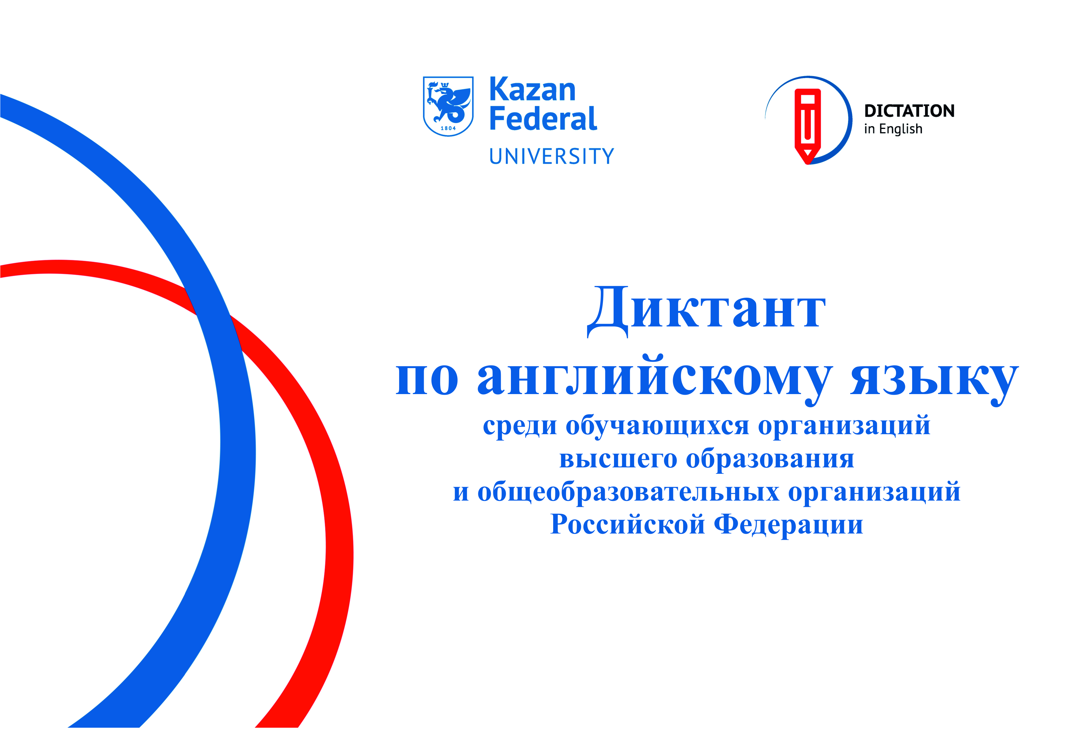
с. Буглен Буйнакский район РД 368210 e - mail: buglen_sch00l@mail.ru

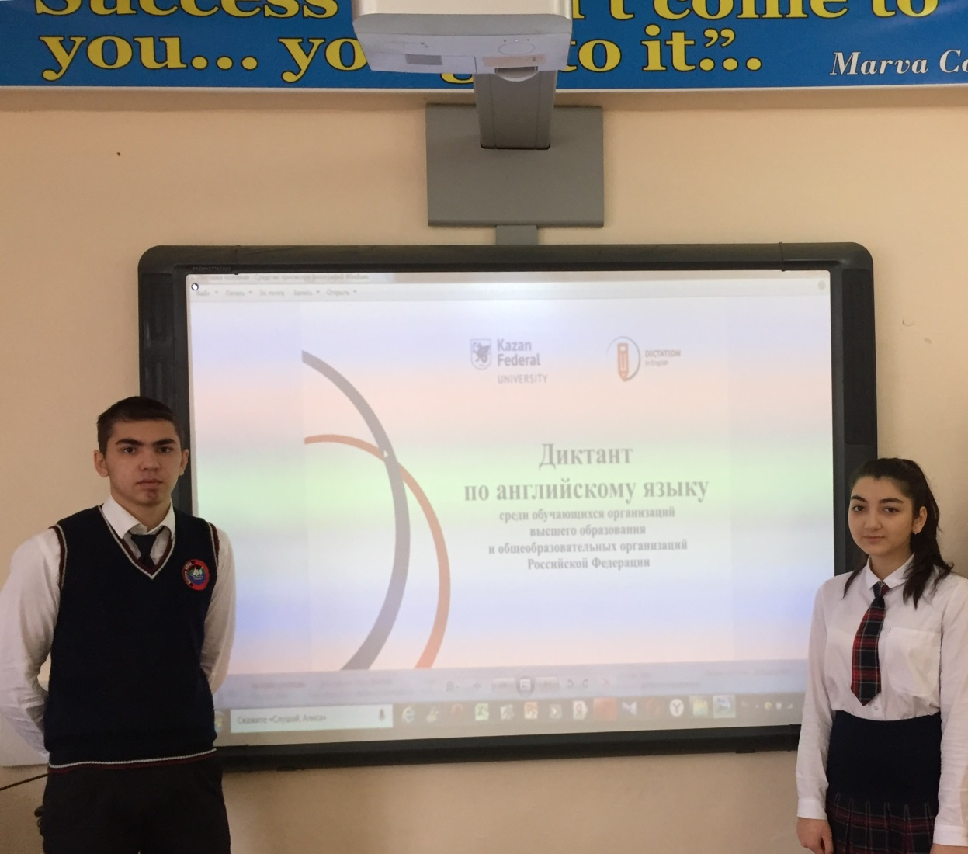

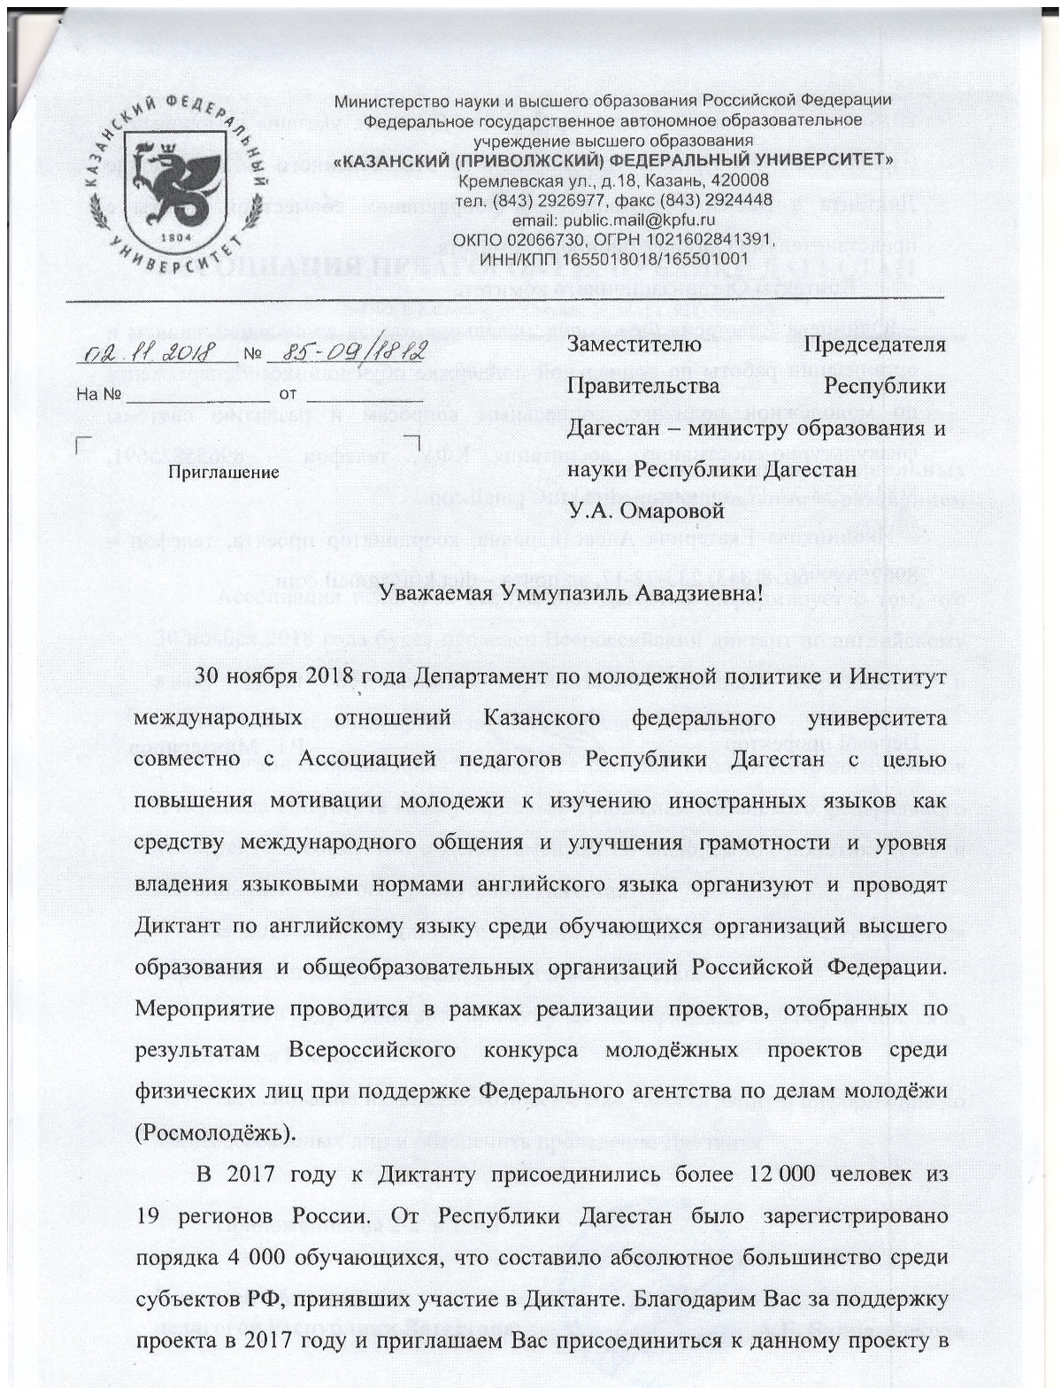

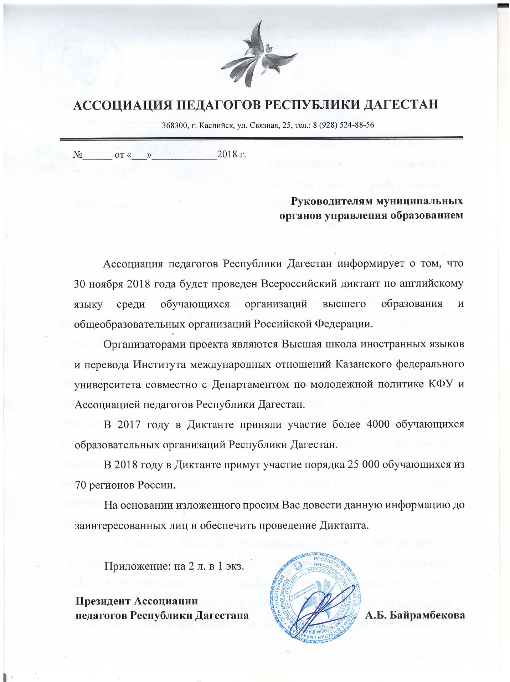

Music in Tolstoy’s Life
Паузация при чтении:
/ пауза 6 секунд
// пауза 10-13 секунд
Выписать на слайде (доске)
Yasnaia Poliana
Kazan Imperial University
“Foundations of Music and Rules for its Study”
gypsies
Tchaikovsky
Mozart
Haydn
Beethoven
Chopin
- Tolstoy’s relations | with music | were reverent | and on occasion | punitive.
- He was fascinated | by the force of music, || just as he was | by the force | of beauty | and war.
- At Yasnaia Poliana | as on most | well-to-do | Russian gentry estates ||, music-making | was as integrated | into daily life | as the making of honey, || boots (,) | or jam.
- As a child | Tolstoy received | basic instructions | in piano | and at 17 | during his study | at Kazan Imperial University | began seriously improving | his keyboard skills.
- Two years later, | in 1849, | he invited | a German pianist | from St. Petersburg | to visit, || whose companionship | inspired him | to sketch out an essay | on the book entitled | “Foundations of Music | and Rules for its Study”.
- It must be emphasized | that Tolstoy never confused | music as art
| with its social |or moral setting.
- Although | visiting the gypsies | might be shameful | according to his rules of life, || Tolstoy always admired | gypsy singing | with its rich tones | and rhythmic variability.
- Throughout the winter | of 1861-62 | he had notable success | in his experimental | Yasnaia Poliana schools | teaching peasant children | the fundamentals of music | through singing.
- He did believe, | however, | that it was essential | to begin right away | with art, | not exercises.
- He was absolutely sure | it was better | not to teach | village children | at all | than to teach them | mechanically.
- He played | a huge variety of music || in four-hand | piano arrangements | with family members | as well as | with visiting musicians.
- Relaxation at the keyboard | could overlap | with literary creativity.
- Tolstoy would sit at the piano || for hours | and improvise (,) | inspiring and focusing his mind || before he got down | to verbal work.
- As a member of the upper nobility, || Tolstoy was acquainted | with all the prominent | Russian composers.
- In 1858, | before the founding | of the first Russian conservatory ||, Tolstoy helped | to set up musical society || in Moscow.
- Tolstoy’s meeting with Tchaikovsky || in 1876 || and their friendship | have left rich traces.
- Tolstoy’s first loves | in music | were not Russian, | but mainstream European |: Mozart, | Haydn, | selected Beethoven (,) | and above all Chopin, | whom Tolstoy called | the musical | equal to Pushkin |in poetry.
- Tolstoy’s fictional use | of dreamed music | is affirmative, | integrative (,) | and blissful.
- He understood art | in general | as a kind | of optimal energy transfer, || with musical art | as the ideal.
(After Caryl Emerson “Tolstoy and Music” from Anniversary Essays on Tolstoy)

