Project
«Ecological and Nature protection activity of my school»
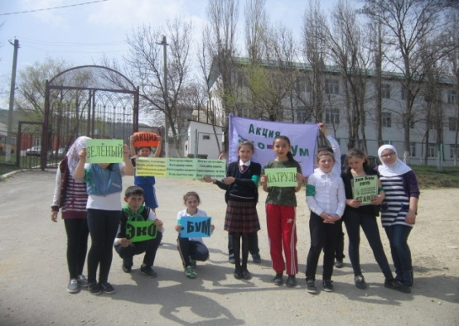

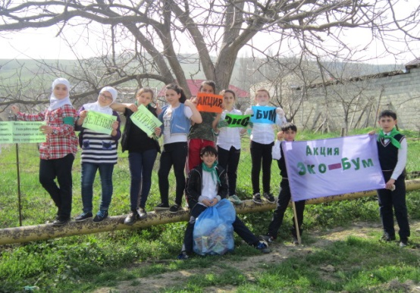

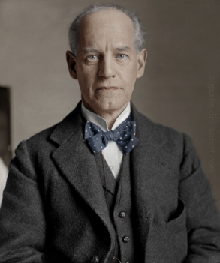

«If you don’t think about the future you will not have it»
John Galsworthy

...it is a wonderful world we living, is not it?
Let’s take care of our home, our planet…
…Who, if not we?
We do it
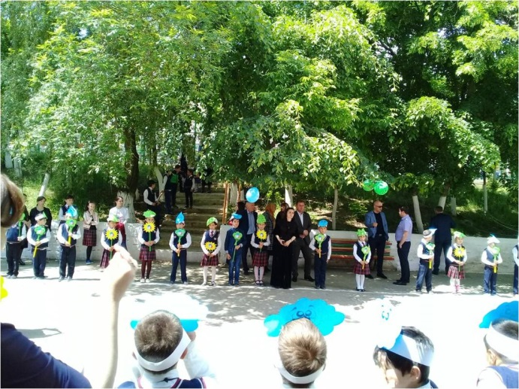
Follow us!

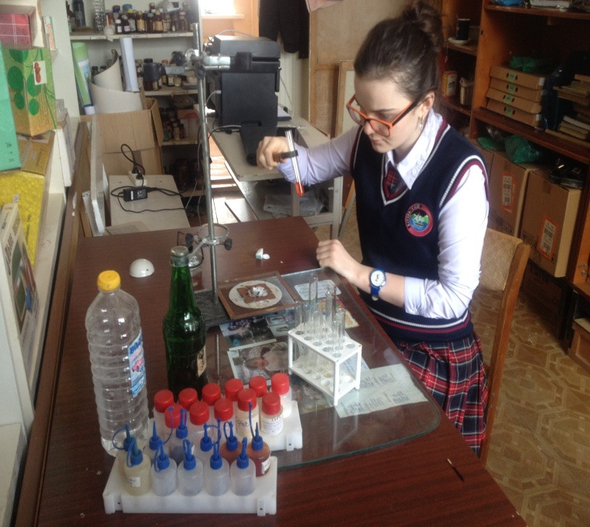
The author of project

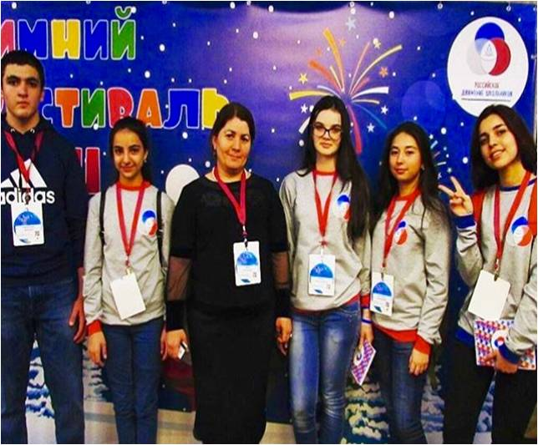

Buglen 2017

Министерство образования и науки РД
МКОУ «Бугленская СОШ имени Ш.И.Шихсаидова»
e-mail: buglenschool@mail.ru
